

Installation / Upgrade Guide

**© 2008-2017 FUJITSU GLOVIA, INC., All Rights Reserved**

Any unauthorized reproduction of this document is prohibited.

**Confidential Information Notice**

This document and the information and know-how it contains constitute a trade secret of FUJITSU GLOVIA, INC. and may not be reproduced or disclosed to others without the prior written permission of FUJITSU GLOVIA, INC.

Table of Contents

Introduction 3

Installing GLOVIA OM 4

Next Steps: 5

Contact: 5

Upgrading GLOVIA OM 6

Next Steps: 7

Contact: 7

# **Introduction**

About this document

This document provides instructions for installing the FUJITSU Enterprise Application GLOVIA OM. Please follow the steps in this document for a successful installation.

**Audience**

This document is targeted for the Salesforce System Administrator who has the responsibility and expertise to setup the application on an existing Salesforce Environment.

**Assumptions**

This document assumes the System Administrator has obtained the FUJITSU Enterprise Application GLOVIA OM to install in a Salesforce Enterprise, Unlimited or Developer Edition.

# **Installing GLOVIA OM**

Follow the steps below to install GLOVIA OM:

Step 1 – Select Contact Me from Get it Now! through the AppExchange or submit a case through [help@glovia.com](mailto:help@glovia.com) to request for an installation link *(****Note:*** *If installing into a sandbox, replace initial URL [https://](https://login.salesforce.com…)****[login](https://login.salesforce.com…)****[.salesforce.com…](https://login.salesforce.com…).. with [https://](https://test.salesforce.com…)****[test](https://test.salesforce.com…)****[.salesforce.com…](https://test.salesforce.com…). )*

Step 2 – Input the installation link into the browser (***Note:*** *Make sure to login to the org)*

Step 3 – Select who you want to install and click **“Install.”**

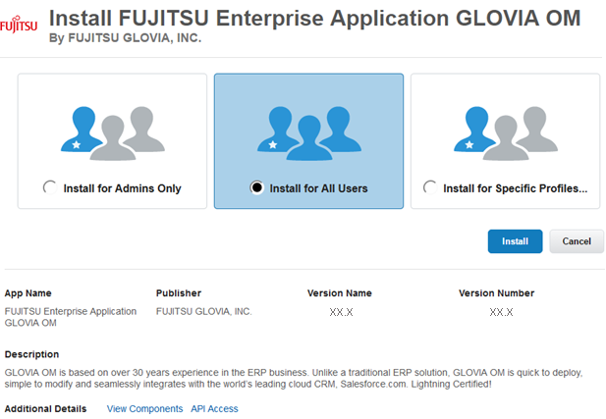

After selecting install, the following message will appear:

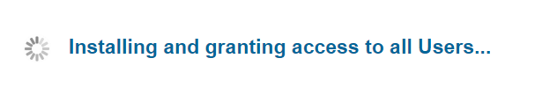

Next, the following message will appear:



You may now close the page by clicking on the button **“Done.”**



Upon completion of the Package Installation, you will receive an email notification.

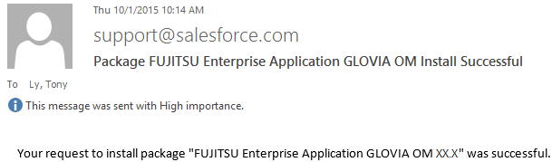

# 

# Next Steps:

Before using GLOVIA OM, configuration is mandatory in order to get started. Please contact [help@glovia.com](mailto:help@glovia.com) for the **GLOVIA OM Configuration Guide.**

# Contact:

If you have any questions about installing the application, please contact: [help@glovia.com](mailto:help@glovia.com)

# **Upgrading GLOVIA OM**

Follow the steps below to upgrade GLOVIA OM:

Step 1 – Select Contact Me from Get it Now! through the AppExchange or submit a case through [help@glovia.com](mailto:help@glovia.com) to request for an installation link

*(****Note:*** *If upgrading a sandbox, replace initial URL [https://](https://login.salesforce.com…)****[login](https://login.salesforce.com…)****[.salesforce.com…](https://login.salesforce.com…).. with [https://](https://test.salesforce.com…)****[test](https://test.salesforce.com…)****[.salesforce.com…](https://test.salesforce.com…). )*

Step 2 – Input the installation link into a browser (***Note:*** *Make sure to login to the org)*

Step 3 – Select who you want to install and click **“Install.”**

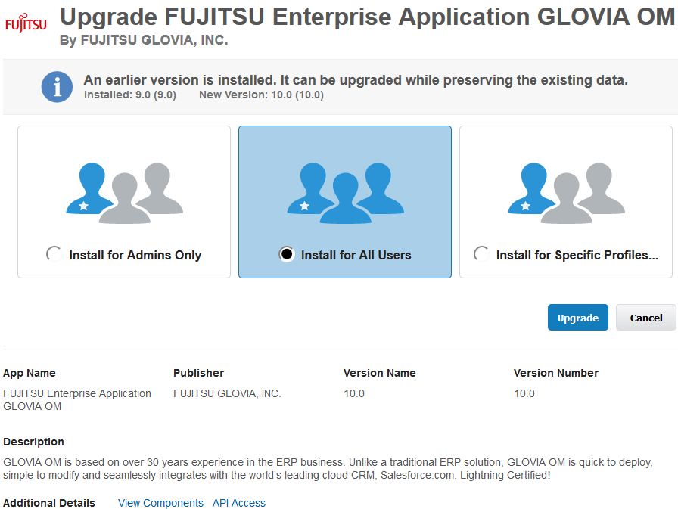

XX.X

XX.X

XX.X

XX.X

When upgrading, the following message will appear:



Next, the following message will appear:



You may now close the page by clicking on the button **“Done.”**



Upon completion of the Package Upgrade, you will receive an email notification.



# Next Steps:

Before using GLOVIA OM, certain page layouts will need to be updated before taking advantage of the new features. Theses page layouts are contained in the upgrade guide. Please contact [help@glovia.com](mailto:help@glovia.com) for the **GLOVIA OM Upgrade Guide.**

# Contact:

If you have any questions about upgrading the application, please contact: [help@glovia.com](mailto:help@glovia.com)